**Boston University**

**Electrical & Computer Engineering**

**EC463 Senior Design Project**

First Semester Report

Submitted to

Andy Whitman and Anthony Byrne

Fathom Fishing

andy@fathom.fishing

abyrne19@bu.edu

by

Team 34

**PUCKFish**

Team Members

Will Aracri waracri@bu.edu

Ammar Hussain hussaina@bu.edu

Peter Ha peterha@bu.edu

Alex Necakov alexrn@bu.edu

Victoria Thomas vmthomas@bu.edu

Submitted: 12/12/2021

**Table of Contents**

**Executive Summary** **3**

**1.0 Introduction** **3**

**2.0 Concept Development** **5**

**3.0 System Description** **8**

**4.0 First Semester Progress** **10**

4.1 Developing and Defining Project Requirements 10

4.2 Research and Development of Conceptual Design 11

4.3 Testing, Implementation, and Planning 12

**5.0 Technical Plan** **13**

5.1 Introduction 13

5.2 Technical Plan 13

5.2.1 Test 3.1 (12/02 - 2/10) 13

5.2.2 Test 2.2: Sensor Array Test (01/02 - 01/28) 14

5.2.3 Test 3.2: Full Hardware Test (01/28 - 02/10) 15

5.2.4 Test 4: Full PUCKFish Functionality Testing (02/10 -04/30) 17

5.2.5 Final Administrative Items (04/30 - 05/18) 18

**6.0 Budget Estimate** **18**

**7.0 Attachments** **20**

**7.1 Appendix 1 – Engineering Requirements** **20**

**7.2 Appendix 2 – Gantt Chart** **21**

**7.3 Appendix 3 – Other Appendices** **21**

# 

# Executive Summary

PUCKFish

Team 34 – PUCKFish

The lobster fishing industry is a historic practice that has largely remained unchanged since its emergence in the mid 1800s. This industry is slow moving, with fishermen only now beginning to adopt more modern practices. One technology that the lobster fishing industry lacks is the ability to use data analytics to determine where lobsters will be. This lack of data leads fishermen to place numerous, extraneous traps throughout the ocean in areas unlikely to house lobsters. While these extra traps do not have an impact on lobsters, they do have a significant environmental impact on other marine life such as the endangered North American Right Whale, a species where lobster trap entanglement is the leading cause of unnatural death. Due to these environmental concerns, heavy regulations are placed on the lobster fishermen, stifling their industry and livelihoods. To solve this problem, we are creating PUCKFish, a low cost data collection unit designed to survive the harsh ocean environment. This device puts data collection and databases into the hands of the fishermen, allowing them to analyze seafloor conditions and make data-backed decisions about where to place lobster traps to truly optimize fishing hauls. We will be producing three PUCKFish data collection devices each recording six key metrics relevant to lobster activity on the seafloor as well as a ship-mounted base station that will receive that data and convert it into a format usable by our clients’ suite of other products for local and aggregated data analytics. PUCKFish will be the first business-grade all-in-one data collection and analysis suite specifically for lobster fishermen. Its cost of below $50 per unit, and ability to collect all of the six key metrics critical to locating and tracking lobsters will revolutionize the lobster fishing industry.

# **1.0** **Introduction**

Currently, the leading cause of death in the critically endangered North Atlantic Right Whale is “entanglements and vessel strikes” (NOAA Fisheries). This issue has caused legislation such as the Marine Mammal Protection Act which effectively illegalizes lobster fishing in large areas of the Atlantic Coast. To protect these animals, lobster fishermen will have to invest in technologies which reduce lobster line pollution. One solution to this issue will be the PUCKFish. As our device will provide fishermen with the information to better approximate the location of lobsters, they will be able to place fewer traps, more effectively, directly decreasing the chances of whale entanglement.

Presently, there is a lack of important data readily available to lobster trappers, with many of them relying on outdated, incomplete historical data to make trap placement decisions. This ultimately forces them into guessing where lobster clusters are, leading to suboptimal use of their limited traps.

Our solution, PUCKFish, will address these issues by giving lobster trappers the most useful data for locating and catching lobsters. From joint studies conducted by NOAA and The Northeast Fisheries Science Center Oceanography Branch, these data points are temperature, dissolved oxygen, salinity, current speed and direction, depth, and ambient light (Manning). This data will then be collected to create one of the most robust oceanographic databases, updated far more regularly and over a wider area than pre-existing databases.

The PUCKFish will be tethered to either the line connecting the trap to the surface buoy or directly to the trap (seen in ***figure 1***). It will collect data once every hour to be transmitted to a base station on the surface every two to three days when the traps are lifted from the water via LoRa radio. Internally, the sensors will be on a printed circuit board (PCB) to reduce size and streamline manufacturing. With certain sensors requiring water contact to collect data, access ports will be included in the design, visualized in ***figure 2.*** The sensing devices will have a battery life of ten days and will be designed to accommodate an easy recharging solution. We will be experimenting with a wireless charging solution to remove a point of failure, as salt water will eventually cause problems with any contact based charging port. With the devices being underwater, they have to withstand continuous exposure to salt water, varying temperatures, and high pressure.

**Figure 1:** Whole system visualization

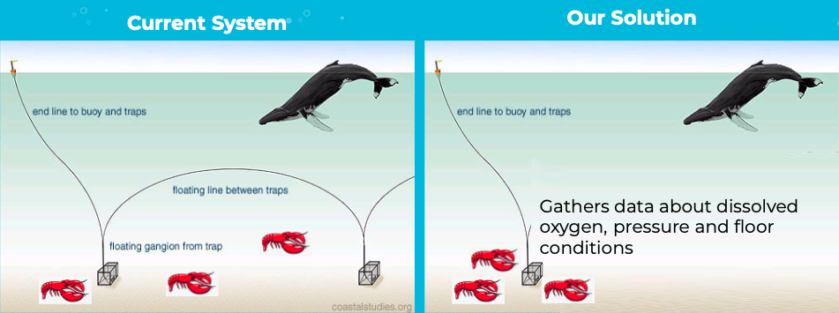

**Figure 2:** Visualization of the puck

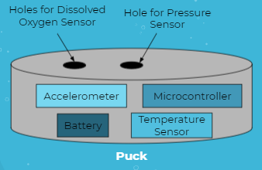

# **2.0** **Concept Development**

Lobster fishermen have been relying on apocryphal data gathered by themselves, and are guided more by instinct and history due to a lack of accessible, accurate data to inform them better where to be placing lobster traps in the ocean to maximize their hauls. As such, lobster traps are operating far below their maximum potential yield and increasing the amount of line pollution in the ocean unnecessarily.

Fathom Fishing is designing data collection and analysis tools and working with fishermen in the lobster fishing industry who would greatly benefit from being able to measure temperature, salinity, dissolved oxygen, ocean current, depth, and ambient light to help find optimal locations for placing lobster traps.

Other products on the market exist that provide some of these metrics. However, they generally rely on the company’s data collection and are not specific to the lobster industry, which necessitates fishermen to pay for expensive licenses and search for databases that contain all of the metrics that they need. The key goal of this project is to put the ability to collect relevant data back into the hands of the fishermen at a much reduced cost and complexity to increase yield per lobster trap and reduce the amount of harmful line pollution in the ocean.

Fishermen are very price sensitive due to the high cost of putting a boat out on the water and deploying/retrieving traps. This price sensitivity is part of the reason that a lack of innovation currently exists in this space, as most fishing vessels have spent tens of thousands of dollars on expensive navigation or data collection suites that are used for over a decade before retirement. Fathom Fishing surveyed many actual lobster fishermen and came to the conclusion that a unit cost of <$50 would allow many fishermen to buy into the Fathom Fishing product line.

We are keeping costs low by selecting cheap but accurate sensors that can be easily integrated into a custom PCB. Fishermen do not require scientific-grade levels of precision in the data collection, which allows us to make sacrifices in sensor quality. Fishermen care more about the general water current speed/direction trend over time and not the precise values that they wouldn’t practically use when fishing.

Another huge consideration we made early on was to design a system with as few moving parts as possible. At 1100ft below sea level, any mechanical components of our device would have to be designed with the ability to operate in incredibly high pressure and low temperature, and likely still be the first pieces to degrade due to exposure. As such, we have prioritized non-mechanical sensors for each of our six key metrics.

A potential issue we identified early on was that the PUCKFish must be tethered by some kind of line to the lobster traps, which could potentially prevent us from using an IMU to collect water current speed and direction accurately. The tether would be adding an additional force to our data that could be hard to model and correct for when doing data analytics.

We explored several more complicated solutions to do current sensing, including using high-precision strain gauges, acoustic doppler sensors, or generating an oscillating magnetic field to do EM based sensing. All of these options would have greatly increased cost and development time. As such, our priority for prototyping was to create a test bed for waterproofing techniques, and to test how accurately an IMU could measure water current while tethered. We used mostly prototype boards and enclosures to conduct this test to keep development time and cost low. Our test results showed that by tethering the PUCKFish to the lines between lobster traps on the seafloor, we would be able to easily back out the force of a tether from IMU data. With this test result, we were able to confidently go with the IMU approach and keep with our minimally mechanically complex design for this metric.

Another critical part of our design was figuring out a cost efficient and minimally mechanically complex way to sense dissolved oxygen. This metric is key to being able to predict where lobster pods will tend to be, as they require a specific amount of dissolved oxygen in the water in order to be able to survive. The problem with sensing this metric is that most out of box dissolved oxygen sensors are scientific-grade equipment with high precision and high cost (a single sensor can cost as much as $150, greater than our entire prototype unit price).

As such, we are exploring several different methods for creating our own dissolved oxygen sensor. We are currently considering two different methods for this sensor, using galvanic and optical methods. The galvanic method requires us to create custom electrodes that sit flush with the exterior of the PUCKFish and is minimally mechanically complex, but the degradation of these electrodes over time is a large factor in unit longevity. The optical method is much more mechanically complex, requiring us to create bubbles in the water and optically measure their size with a built-in camera. This method would be much harder to produce and necessitate a significantly larger battery to power the bubble-making and sensing components even during idle use.

Making the PUCKFish easily rechargeable was another key design problem we grappled with. A traditional wired charging port would either require complicating the PUCKFish shell with a pressure/water-proof seal to prevent water from seeping in, or creating a totally waterproof charging port. This would still be a huge point of failure, as the metal contacts in a charging port would quickly degrade with prolonged exposure to seawater.

After doing a feasibility analysis, we decided to use wireless charging in the PUCKFish. With wireless, we totally eliminate the design challenges imposed by a physical port on the device, increasing mechanical integrity while keeping functionality. Eliminating all physical ports will require us to use wireless transmission to perform data recovery or update firmware on a unit, but will greatly drive down development time needed in the mechanical engineering side of the project.

Choosing a battery type was not a huge concern of ours during development as we have had experience working with rechargeable LiPo batteries, and were heavily pushed in that direction by our microcontroller vendor (Adafruit) setting the source voltage level we needed at the single cell LiPo range. Our goal is to choose the minimum possible capacity for the LiPo that we can get away with, as the battery will eat into the limited space within the PUCKFish enclosure, as well as our actual budget.

We have done some preliminary battery life calculations to figure out this minimum needed capacity to hit our target requirement of 10 days on a single charge, but still need to select a dissolved oxygen sensor design to complete this calculation. As of now, we believe we can get away with a battery with capacity as low as 500 mAh to get us through our 10 day requirement. However, we are aware that LiPo batteries lose some capacity at the low temperatures found on the ocean floor, and are factoring that in as a margin of safety to achieve the desired operating time.

| **Concept Development Method Analysis** | | | |
| --- | --- | --- | --- |
| **Metric** | **Method** | **Pros** | **Cons** |
| Water Current Speed/Direction | IMU | * Mechanically simplest solution * Low ingress risk * Low power draw * Cheap, readily available sensors | * Relatively low precision * Requires characterization of flow around puck |
| EM Sensing | * Mechanically simple * Low ingress risk * Electrically simple * Accurate reading | * Requires development of new sensor * High power draw for readable voltage * Dependant on accurate salinity/conductivity data |
| Acoustic Doppler Sensing | * State of the art in industry * Extremely accurate readings | * Extremely expensive * High volume requirement * High power draw |
| Mechanical | * Extremely simple * Accurate reading * Low power draw | * Sensor or mechanism will inevitably fail * Depending on implementation, higher ingress risk |
| Dissolved Oxygen | Galvanic | * Self polarized, don’t require time to warm up * Accurate measurements * Easy to set up | * Zinc electrode corrodes and needs to be replaced periodically * Requires electrolyte solution to measure DO2 |
| Optical | * Don’t require electrodes to measure current * Will last longer | * Sensors are very expensive ($700+) |
| Titrimetric | * Widely used standard procedure * Consistent results | * Subject to human error * Requires careful calibration |

| **Estimated Power Budget** | | |
| --- | --- | --- |
| **Component** | **Active Current Draw (mA)** | **Passive Current Draw (uA)** |
| LoRa Radio | 120 | 300 |
| Pressure Sensor | 1.25 | 0.1 |
| Ambient Light Sensor | 0.25 | 5 |
| Salinity Sensor | 8.5 | 3 |
| Ocean Current Sensor | 1.9 | 6 |

# **3.0** **System Description**

The scope of PUCKFish entails three prototype “pucks” and a base station. Each puck will be mounted to a separate chain of lobster traps, collecting data for that cluster. When surfaced, the puck will detect it has surfaced via its pressure sensor, and wirelessly transmit the data it collected in JSON format over LoRA to the base station. The base station will then collect the data for processing. The data will be stored locally on a removable SD card in CSV format, and can be uploaded to the cloud for further processing and aggregation with other trappers’ data, depending on the trapper’s implementation of Fathom’s cloud services.

Each puck will be equipped with sensors for collecting: temperature, pressure, conductivity, dissolved oxygen, ambient light, and orientation/acceleration. Sensor models are tabulated in table 4, in section 6. While most variables are used directly, we will develop models to extrapolate salinity from conductivity, dissolved oxygen from a camera, and water current from orientation. These variables were requirements from our client, and are the most crucial to predicting aquatic life; they were specifically recommended by NOAA’s similar eMOLT project and professional lobster trappers.[1]

Conductivity will be measured by applying a known voltage across two electrodes exposed to seawater, and measuring the resulting current to find resistance.

We intend to use a COTS galvanic dissolved oxygen sensor, as the design and manufacture of an oxygen sensor is unfeasible with our group’s capabilities and timeline. Such solutions revolve around measuring the current between two dissimilar metals, prompting the oxidation of the anode. This solution will return extremely accurate results. That said, COTS solutions are on the order of $170, so we will continue to investigate. Our client has approved the purchase and reverse engineering of existing solutions to try and cut costs.

Water current is measured using acceleration and orientation data from an inertial measurement unit. Characterization of the movement of the puck in water under different flows will be completed following extensive testing under different conditions. This will allow us to create a model that converts the acceleration and oscillation of the puck to approximate water current. This method has inherently low precision, but our client only requires approximate current readings, to give trappers a general idea of ocean currents. Specifically, they plan to inform trappers of “low, medium, or high” current, as well as direction. Preliminary testing in the lazy river at BU’s Fitness and Recreation Center demonstrated we are able to back out relative current strength and approximate direction from IMU data. Using this as proof of concept, we will move forward with more accurately characterizing puck movement under flow.

Sensors will be connected to the microcontroller, a Feather M0 w/ RMF95 LoRa from Adafruit, via I2C and powered through the same. The microcontroller will in turn be powered from a lithium polymer battery, on the order of 500 mAH, pending further testing and requirements of power budget. We expect some reduction in capacity due to the low temperatures at 1100ft below sea level,[2] but this can be fixed by oversizing our battery by approximately 15 percent.[3] Battery will be saved by only polling sensors once per hour, dramatically reducing power consumption and battery life so it can meet the required 10 days deployed. The battery will be charged using inductive wireless charging, reducing mechanical complexity and removing a possible port of ingress. While we can license an existing wireless power standard, the team is also investigating custom solutions to avoid the fees associated with Qi or other competing standards.

The puck is rated to survive for extended periods at depth in the harsh oceanic environment. This will be achieved by fully encasing the electronics in a marine grade epoxy, using a custom mold. This methodology is commonly used in marine applications,[4] and benefits from epoxy’s waterproof and anti-corrosive properties.[5] This prevents the need for a complicated sealing system, which would likely employ a consumable seal such as an o-ring or teflon tape and eventually fail due to corrosion and leakage. It additionally gives total freedom in designing a casing that both keeps water out from delicate components, as well as allowing saltwater access for sensors that require it. The final advantage of such a system is being able to cast to any general shape, particularly those for which hydrodynamic characterization is already well studied. This dramatically simplifies the modeling process by falling back on well known and understood flow models, for example, around a sphere.[6]

**Figure 3:** System Block Diagram

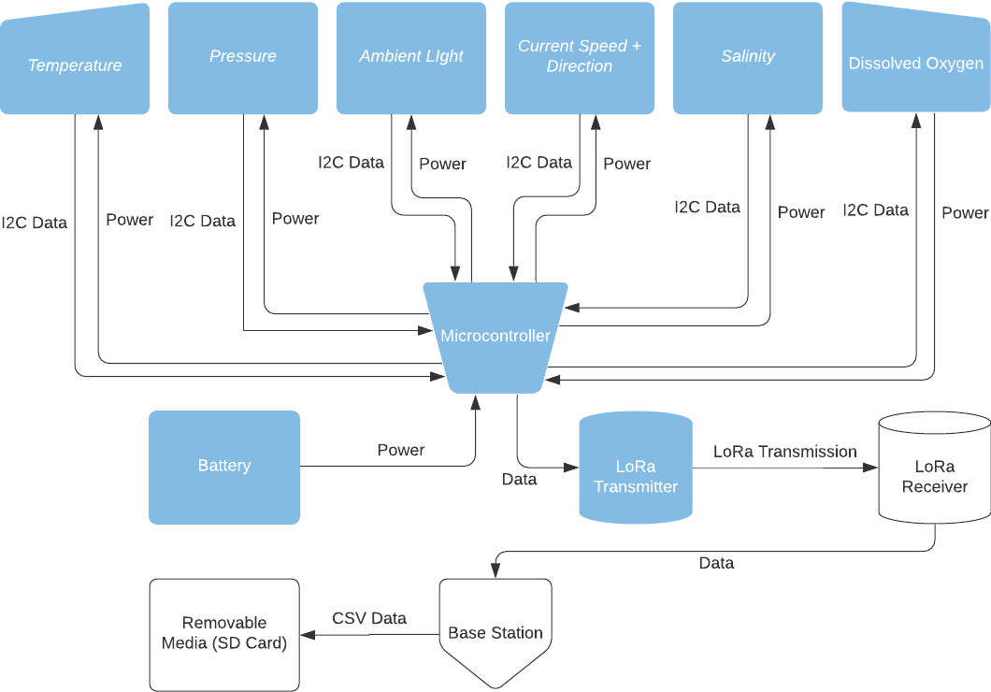

# **4.0** **First Semester Progress**

The technical development of PUCKFish can be divided into separate periods in which the team was focused on separate technical details: defining and refining requirements; research and development of a first prototype; and development of a testing plan and path forward, as well as testing the conceptual hardware that would be used in the prototype.

## 4.1 Developing and Defining Project Requirements

Early September was primarily focused on getting acquainted with the problems involving data acquisition at extreme depth and pressure. This research included general sensor architectures and methods, as defined by our initial requirements, as well as the design of pressure and corrosion resistant enclosures that can hold water-tight seals under 30 atmospheres of pressure. On September 27th, with the researched values and metrics, the team met with the client and used the time to adjust requirements and quantify accuracy and precision of the sensors required to reach success metrics. On October 4th, these findings were assembled into a PDRR presentation that was shown to the ECE class. These requirements can be found in ***appendix 1***. In addition, competitive analysis was conducted to affirm that the requirements successfully provided PUCKFish with a competitive advantage.

## 4.2 Research and Development of Conceptual Design

With the requirements for the project properly defined, the team developed a strategy to determine minimum viable technologies that would perform at the prototype level. On October 18th in a joint meeting with the customers, a parallel technical path was developed in order to accomplish these goals.

The first of these paths included the development of the electronics and sensor array that would command and power PUCKFish. The electrical engineers took in the requirements developed through the PDRR stage. Ammar took the responsibility of selecting the dissolved oxygen, salinity and temperature sensors. Alex took the responsibility of the requirements involving the remaining sensors, microcontroller selection, radio transmission, and battery.

The latter of these paths included the development of the current sensing technology. This became its own path because the selection of the concept meant large-scale changes for the overall architecture of the PUCKFish. There were two main concepts for sensing the water currents around PUCKFish. The first idea was an inductive coil that would provide a back-voltage when saltwater would traverse through the coil. The second concept was developing an architecture that would be buoyant. When the current pushed the tethered buoyant enclosure, an IMU could be used to find the orientation of the enclosure and the orientation could be backtracked to find the force of the current, which in turn would provide the speed and direction of the water flow. Peter took the responsibility of researching and developing an inductive coil capable of measuring water current and Will took the responsibility of developing an IMU concept to measure current. Victoria would support both Peter and Will with manufacturing considerations. On October 15th, the design of an IMU test enclosure (see appendix 7.3.2) was completed and in late October, it was determined that the power draw for an inductive measuring device would be too great to sustainably power over the time period required by that of PUCKFish. The path forward became clear and on October 18th, Victoria and Will completed the manufacturing of the IMU current sensing concept .(see appendix 7.3.3 and 7.3.5)

On November 6th, Alex completed a preliminary electronics set up featuring the IMU, a LoRa radio and antenna, and a rechargeable lithium ion battery that transmitted data collected from the IMU (see appendix 7.3.4). From there he began researching final electronics requirements for PUCKFish. On November 9th, Ammar completed an initial selection of the required sensors with the exception of the dissolved oxygen sensor. At this point, the computer and IMU set up were ready to integrate into the IMU enclosure.

Preliminary testing for water testing was completed on November 14th by submerging the enclosure in a bathtub overnight and the results proved the enclosure was safe for electronics testing.

## 4.3 Testing, Implementation, and Planning

On November 15th, we began developing a testing plan with Will leading the procedure for the first test. The testing plan laid out future requirements for technical progress was completed on November 16th. During the November 16th test in the senior design lab, data was successfully collected and transmitted over radio from the IMU. Although the enclosure could not be tested underwater because of an inability to fill the water reservoir in the lab, the team determined that the test was successful as the enclosure was tested for waterproofing in a previous test. Due to the completion of Test 1.1, the team could begin following the testing plan featured in appendix section 7.3.1.

On November 22nd, the team prepared a testing procedure for Test 2.1 to test the IMU in FitRec’s Lazy River facility. On the same day, testing was carried out and data was collected. The team is still currently working on the model for taking the data and determining the best path forward for how the data will be used to determine the current velocity and direction. Given the requirements to determine water current qualitatively, the team determined that further testing to characterize the flow requirements would be needed and this metric would be wrapped into a future test within the test plan framework.

On November 29th, the team met to discuss the requirements for the PDR. Of these determinations were architecture concerns with electrical requirements. Primarily of interest was the charging method for the battery installed on PUCKFish. It was determined that for a first attempt at charging would involve wireless charging technology. Alex and Ammar began researching this approach and determined feasibility to acquire a license for future testing, wrapped in with Test 3.2. In addition, the mechanical engineers began work on sensor ports and the final enclosure design which would be featured in Test 3.1. Also discussed in this meeting was the creation of a technical path forward. This would be completed as a Gantt chart for the PDR.

On December 2nd, the PDR and technical path forward were completed and presented for review. The presentation was reviewed favorably and confirmed our assumptions of waterproofing and overall electronics architecture. On December 3rd, the Mechanical engineers began development of the final enclosure and ports in preparation for Test 3.1 and the electrical engineers began preparing for the sensor array test for Test 2.2.

# **5.0** **Technical Plan**

## 5.1 Introduction

The technical path forward was produced as a result of the tests necessary to develop a full prototype. As discussed before, the challenges with PUCKFish revolve around the data collection, as well as the harsh underwater conditions that must be accounted for. The tasks are divided to reach a successful prototype by the time the project is due during the week of April 1st and allows time for iteration and redesign so that successful customer integration is achieved by May 1st 2022.

For ease of reading, Power requirements, accuracy and precision figures, and other technical details are precluded from the technical plan. Values for requirements and technical requirements can be found in the appendix and are assumed to be counted as objectives for each task. When “Sensors” appears, this means all sensors as determined by the requirements listed in the appendix and preceding sections unless otherwise noted.

## 5.2 Technical Plan

### 5.2.1 Test 3.1 (12/02 - 2/10)

**Task 1: Develop and Design Enclosure for Full Depth Pressure (12/02 - 12/18)**

An enclosure will be developed in order to fit a custom 2”x6” PCB. The enclosure shall be water tight up to 30 bars of pressure. The enclosure shall accommodate the required mechanical mating mechanism to allow for wireless charging to take place but also be modifiable in the event that charging method must change. The enclosure shall feature integration features that allow the integration of sensor ports

**Lead**: Peter Ha **Assisting**: Will Aracri

**Task 2: Develop and Design Sensor Ports (12/02 - 12/18)**

Ports shall be developed for each sensor that needs exposure to the water to successfully accomplish a measurement per the requirements. Ports shall be water tight up to 30 bar of pressure. Ports shall be designed in order to successfully integrated to the enclosure features completed in Task 1

**Lead:** Victoria Thomas **Assisting:** Will Aracri

**Task 3: Manufacture Enclosure (01/21 - 01/28)**

The enclosure shall be manufactured per the requirements determined by the design featured in task 1. The enclosure shall be manufactured within the limitations of EPIC capabilities

**Lead:** Victoria Thomas **Assisting:** Peter Ha

**Task 4: Manufacturer Sensor Ports (01/21 - 01/28)**

The sensor ports shall be manufactured per the requirements determined by the design featured in task 2. The sensor ports shall be manufactured within the limitation of EPIC capabilities.

**Lead:** Victoria Thomas **Assisting:** Will Aracri

**Task 5: Integration: Sensor Ports and Enclosure**

The sensor ports and enclosure shall be integrated together. Any issues with integration including miss-fits or any other challenges shall be addressed and iteration or redesign will take place.

**Lead:** Peter Ha **Assisting:** Victoria Thomas

**Task 6: Testing Plan (01/28 - 02/04)**

The testing plan for test 3.1 shall determine the method in which the enclosure will be tested to 30 bar. The testing plan will determine requirements for the quality of water proofing. The testing plan shall include a measurable quantity to associate the required amount of water proofing to achieve successful operation

**Lead:** Will Aracri **Assisting:** Victoria Thomas, Peter Ha

### 5.2.2 Test 2.2: Sensor Array Test (01/02 - 01/28)

**Task 1: Select Sensors (10/02 - 12/03)**

Task 1 was successfully completed this semester by Ammar Hussain. These sensors are featured in the appendix

**Task 2: Complete Electronics Design (11/15 - 12/16)**

A complete electronics design shall accommodate all sensors per the requirements. The electronics design shall collect data and relay the data back to a computer for data analysis. The electronics design shall be able to sustain 1 hour of operation time. The electronics design shall allow for easy maintenance so that interactive design may take place

**Lead:** Alex Necakov **Assisting:** Ammar Hussain

**Task 3: Internal Design Review ( 12/16 - 12/16)**

An internal design review shall cover the design of the sensor array testing electronics. An internal design review shall cover the precision of the sensors, the sample time that are achievable, and shall cover methods of operation

**Leads:** Alex Necakov, Ammar Hussain **Assisting:** Victoria Thomas, Will Aracri, Peter Ha

**Task 4: Functional Testing (01/20 - 01/22)**

Functional testing shall prove data can be collected from the sensor array. Functional testing shall prove data may be uploaded to a computer for review. Functional testing shall confirm operating procedures of the sensor array

**Lead:** Alex Necakov **Assisting:** Will Aracri

**Task 5: In-Water Test (01/22 - 01/24)**

An in-water test shall develop a controlled test environment where data may be retrieved with known values. An in-water test shall collect data from the controlled test environment and be relayed back to a computer for further analysis

**Lead:** Alex Necakov **Assisting:** Will Aracri

**Task 6: Data Analysis (01/24 - 01/26)**

Data analysis shall take data as a result of the in water test and compare the data to the known values of the controlled test environment. A data analysis test shall provide proof that sensors are developing accurate data to the precision per the requirements.

**Lead:** Alex Necakov **Assisting:** Will Aracri

**Task 7: Iteration Time (Optional) (01/26 - 01/27)**

Iteration time shall adjust the sensor array electronics so that data may be read successfully if not deemed successful by the data analysis. Iteration time shall change the design per success.

**Lead:** Alex Necakov **Assisting:** Ammar Hussain

**Task 8: In-Water Test 2 (Optional) (01/27 - 01/28)**

An in-water test shall develop a controlled test environment where data may be retrieved with known values. An in-water test shall collect data from the controlled test environment and be relayed back to a computer for further analysis. A second In-Water test shall prove that iterations made during task 7 were successful.

**Lead:** Alex Necakov **Assisting:** Will Aracri

### 5.2.3 Test 3.2: Full Hardware Test (01/28 - 02/10)

**Task 1: Develop and Design PUCKFish Computer (01/28 - 02/06)**

A computer shall be designed to collect the sensor data from the current sensing data and the sensors proved out from Test 3.2. The computer shall relay the sensor data to a base station. The computer shall be approximately 2in in width and 6 inches in length and 1 inch in thickness.

**Lead:** Alex Necakov **Assisting:** Ammar Hussain

**Task 2: Develop and Design PUCKFish Power Supply (01/28 - 02/06)**

A power supply shall be designed to power the PUCKFish computer for a duration of 10 days. The power supply shall be designed to recharge via the recharge method determined, either wirelessly or through leads provided to the mechanical engineering team.

**Lead:** Ammar Hussain **Assisting:** Alex Necakov

**Task 3:**  **Internal Design Review (02/04 - 02/04)**

An internal design review shall inform the mechanical engineering team of the dimensions of both the power supply and the puckfish computer. An internal design review shall show methods of operation. An internal design review shall determine unknowns meant to be uncovered during testing to the team.

**Leads:** Ammar Hussain Alex Necakov **Assisting:** Peter Ha, Victoria Thomas, Will Aracri

**Task 4: Testing Plan: Functionality (02/07 - 02/07)**

A testing plan shall determine a controlled environment for the sensors to collect data from the water with the exception of current velocity. A testing plan shall include requirements for sensor data accuracy. A testing plan shall determine a method to test radio transmission of the data to a base station or computer.

**Lead:** Alex Necakov **Assisting:** Ammar Hussain

**Task 5: Testing Plan: Battery Life Test (02/07 - 02/07)**

A testing plan shall determine a controlled environment where the life of the battery may be determined. The testing plan shall include requirements to determine the successful recharging of the battery. A testing plan shall include an integration plan to bring the power supply system together with the functional PUCKFish computer.

**Lead:** Ammar Hussain **Assisting:** Alex Necakov

**Task 6: Functionality and Battery Life Testing (02/07 - 02/10)**

Functionality and Battery Life testing shall provide a full duration (10 day) test of the computer collecting and transmitting data to a base station. Functionality and Battery Life testing shall prove that the battery may be successfully recharged after a full duration test. Functionality and Battery life testing shall follow the procedures developed in Task 4 and Task 5.

**Lead:** Will Aracri **Assisting:** Ammar Hussain, Alex Necakov, Victoria Thomas, Peter Ha

### 5.2.4 Test 4: Full PUCKFish Functionality Testing (02/10 -04/30)

**Task 1: Final Iteration and Adjustments (02/10 - 03/21)**

Final iteration and adjustments shall fix bugs found in Test 3.1 and Test 3.2. Final iteration and adjustments shall provide an integration plan between the mechanical enclosure developed from test 3.1 and the electronics hardware in Test 3.2.

**Leads:** Alex Necakov, Peter Ha **Assisting:** Victoria Thomas, Ammar Hussain, Will Aracri

**Task 2: Testing Plan: Full Functionality Testing (03/21 - 03/27)**

A testing plan shall provide an environment where PUCKFish’s sensors may be evaluated. A testing plan shall provide procedures for operating PUCKFish. A Testing plan shall determine the appropriate methods to evaluate the success of operation and data collection of the final PUCKFish design. A testing plan shall provide a method to test PUCKFish to at least 2 full work cycles.

**Leads:** Alex Necakov, Victoria Thomas, Peter Ha, Ammar Hussain, Will Aracri

**Task 3: Full Functionality Test (03/28 - 04/01)**

A full Functionality Test shall be performed to the procedure determined by Task 2. A full functionality test shall note difficulties in operating PUCKFish for later review.

**Leads:** Alex Necakov, Victoria Thomas, Peter Ha, Ammar Hussain, Will Aracri

**Task 4: Testing Review (04/01 - 04/02)**

A testing review shall determine if the test performed during task 3 reached the success parameters determined by task 2. A testing review shall determine path forward for possible further iterations and adjustments.

**Leads:** Alex Necakov, Victoria Thomas, Peter Ha, Ammar Hussain, Will Aracri

**Task 5: Iteration and Adjustments (Optional) (04/02 - 04/29)**

Iterations and adjustments shall address the shortcomings in either operation or accuracy to the project requirements as discovered during Task 4. Iterations and Adjustments shall complete any final requirements for PUCKFish to become operational

**Leads:** Alex Necakov, Victoria Thomas, Peter Ha, Ammar Hussain, Will Aracri

**Task 6: 2nd Functionality Test (04/29 - 04/30)**

A second functionality test shall be performed like Task 3 to determine if the Iterations and Adjustments were successful in reaching the goals defined in Task 2: Full Functionality Testing Plan

**Leads:** Alex Necakov, Victoria Thomas, Peter Ha, Ammar Hussain, Will Aracri

### 5.2.5 Final Administrative Items (04/30 - 05/18)

**Task 1: Customer Installation (04/30 - 05/18)**

Customer installation shall provide cooperation between the end user customers and the PUCKFish development team. Customer Installation shall provide feedback on the final PUCKFish designs. Customer Installation shall only consist of operational changes to PUCKFish with no architecture changes to the direct product itself

**Leads:** Alex Necakov, Victoria Thomas, Peter Ha, Ammar Hussain, Will Aracri

**Task 2: ECE Day (05/06 - 05/06)**

ECE Day shall be completed per the requirements given to the team by the course.

**Leads:** Alex Necakov, Victoria Thomas, Peter Ha, Ammar Hussain, Will Aracri

# **6.0** **Budget Estimate**

| **Item** | **Qty** | **Unit Cost** | **Total** | **Vendor** |
| --- | --- | --- | --- | --- |
| Feather M0 w/ RMF95 LoRa | 1 | 34.95 | $34.95 | Adafruit |
| MS583730BA01-50 (Depth/Temp) | 1 | 12.59 | $12.59 | Digikey |
| LTR-329ALS-01 (Amb. Light) | 1 | 1.06 | $1.06 | Digikey |
| ZXCT1107SA-7 (Salinity) | 1 | 0.92 | $0.92 | Digikey |
| ICM-20608-G (IMU) | 1 | 7.44 | $7.44 | Digikey |
| Lithium Ion Polymer Battery | 1 | 7.95 | $7.95 | Adafruit |
| Raspberry Pi Zero 2 W | 1 | 15.00 | $15.00 | Adafruit |
| 32GB SD card | 2 | 9.95 | $19.90 | Adafruit |
| Dissolved Oxygen Sensor (Camera) | 1 | 12.50 | $12.50 | Adafruit |
| Device Casing (PVC Pipe) | 1 | 23.95 | $23.95 |  |
| Marine Epoxy | 1 | 50.00 | $50.00 | ProMarine Supplies |
| Other Assorted Mechanical Items | 1 | 20.00 | $20.00 | N/A |
|  |  | **Total Estimate:** | **$206.26** |  |

*Table 4. Estimated Budget*

# 

# **7.0** **Attachments**

# **7.1** **Appendix 1 – Engineering Requirements**

Team # 34 Team Name: PuckFish

Project Name: PuckFish

| **Requirement** | **Value, range, tolerance, units** |
| --- | --- |
| Price | Less than $150 per prototype |
| Depth and Pressure | Operate fully-submerged in saltwater at depths up to 1100ft and at a pressure of over 34.4 atm |
| Sensors | Contain sensors for detecting temperature, depth (hydrostatic pressure), salinity (conductivity), dissolved oxygen, and ambient water current, speed, and direction |
| Collection Frequency | Collect sensor data at least once per hour for up to 10 days on a single charge |
| Surfacing | Automatically detect when it has been submerged or has surfaced |
| Data Transmission | Wirelessly transmit up to 1 megabyte of data at a minimum rate of 50 kilobits/second to a base station up to 50ft away |

# **7.2** **Appendix 2 – Gantt Chart**

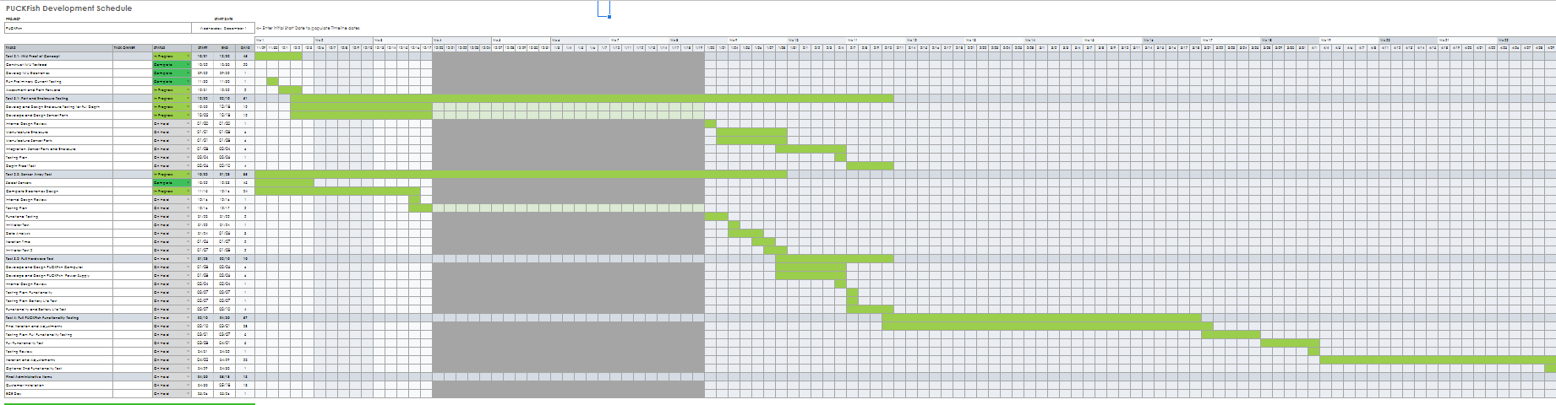

# **7.3** **Appendix 3 – Other Appendices**

7.3.1 Testing Path

**7**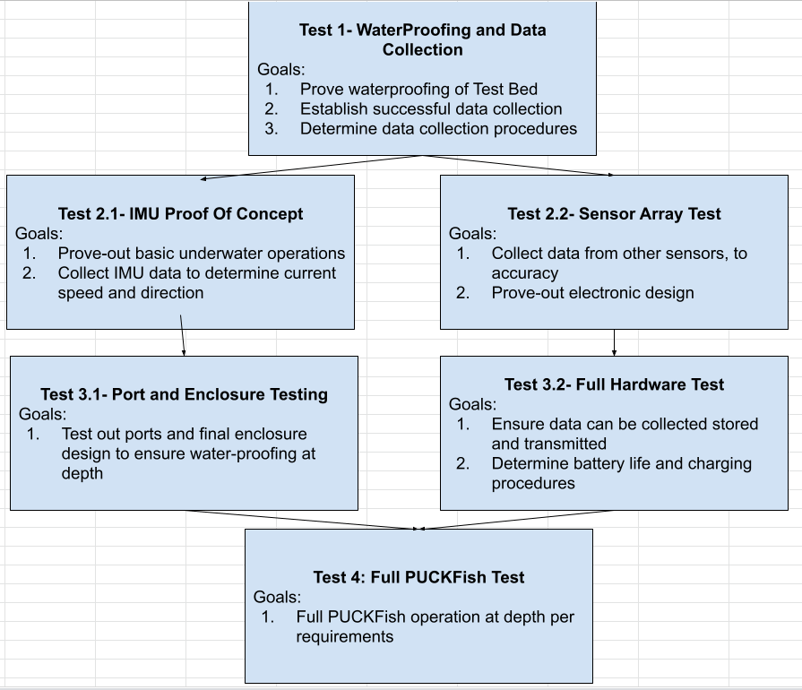

7.3.2 IMU Test Pill: Concept

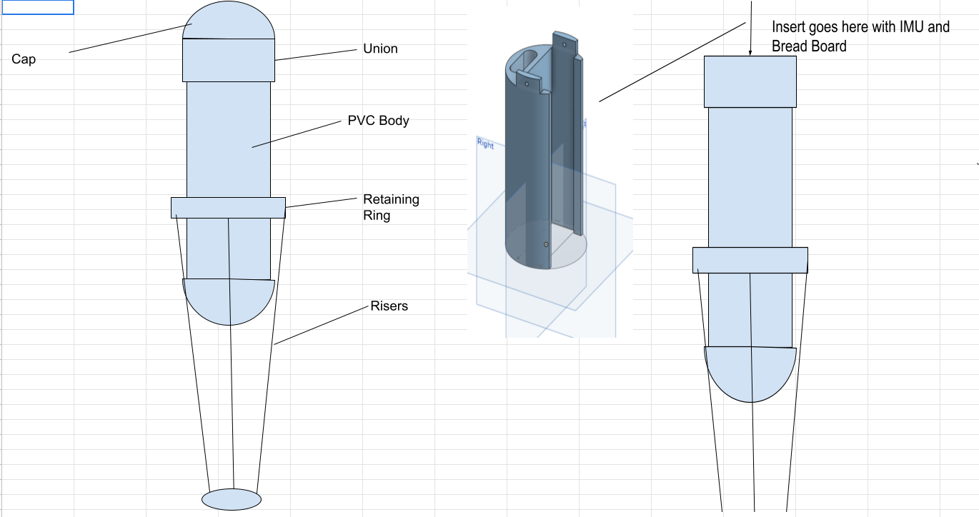

7.3.3 IMU Test Pill: Enclosure

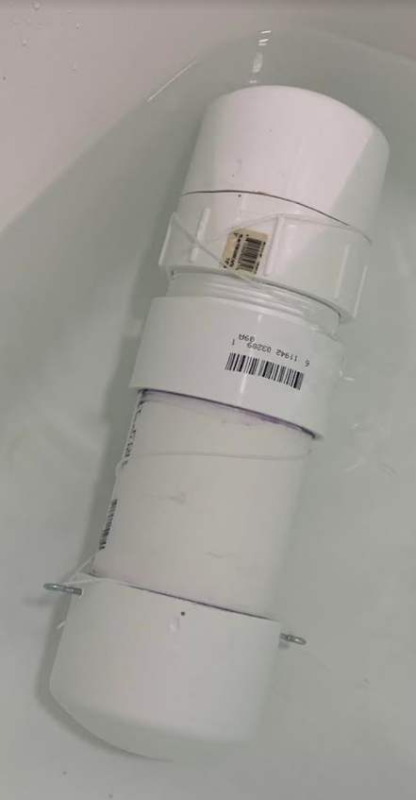

7.3.4 IMU Test Pill: IMU and Teensie

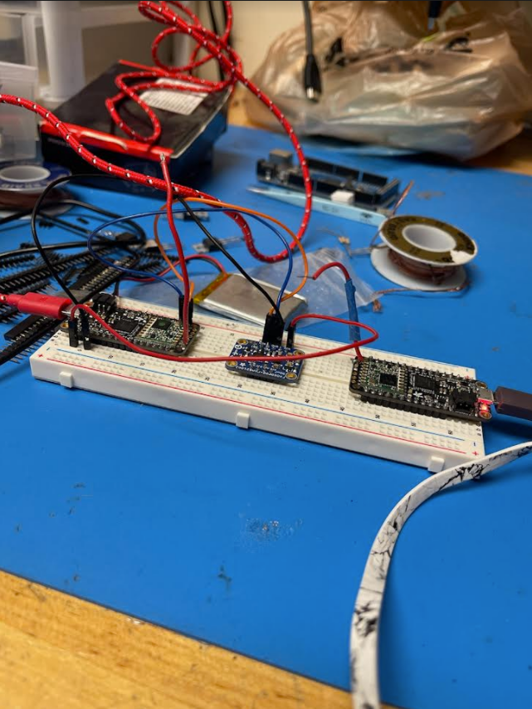

7.3.5 IMU Test Pill: Computer Chassis in the process of printing

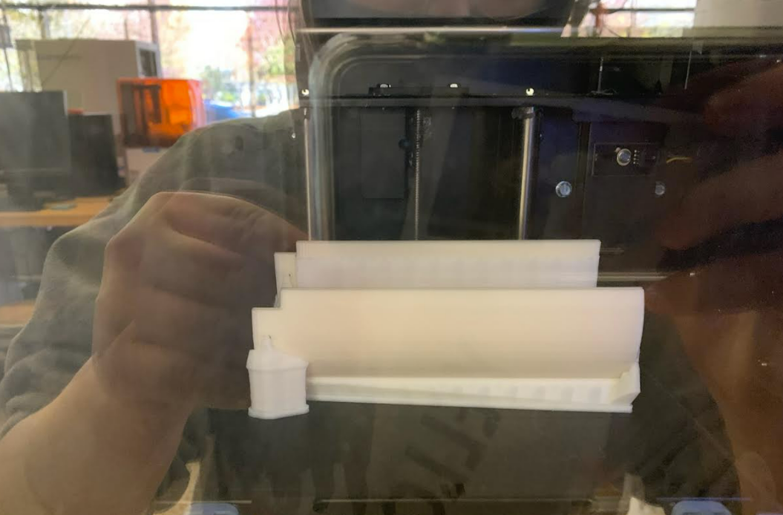

7.3.6 Team Biographies and History

**Alex Necakov (CE 2022) -** [**alexrn@bu.edu**](mailto:alexrn@bu.edu) **(203)-822-3119**

Alex is an undergraduate pursuing a B.S. in computer engineering at Boston University. Although specializing in software engineering, Alex has gained experience in a breadth of ECE related fields from work in robotics and rocket electronics design. Working with embedded electronics has been his main takeaway from his undergrad experience, which translates directly to his work on the ECE side of PUCKFish.

**Victoria Thomas (ME 2022) - vmthomas@bu.edu**

Victoria is pursuing an undergraduate degree in mechanical engineering with an aerospace concentration from Easton, MA. Due to her significant hands-on manufacturing experience, Victoria is able to provide manufacturing planning and processes. In this semester she performed water testing on this device and helped to design and create the electronics bed.

**Ammar Hussain (EE 2022) -** [**hussaina@bu.edu**](mailto:hussaina@bu.edu) **(617)-281-9858**

Ammar is an undergraduate pursuing a B.S. in electrical engineering at Boston University. He is from Brookline, MA with experience in microelectronic circuits, and has an interest in sensor development. Additionally, he has long had a passion for marine biology and hopes to combine interest with his technical background to PUCKFish.

**Will Aracri (ME 2022) -** [**waracri@bu.edu**](mailto:waracri@bu.edu) **(412)-952-8185**

Will is an engineering student from Pittsburgh PA. After spending a year and a half in industry, he came back to Boston to complete his degree. He specializes in testing and manufacturing procedures.

**Peter Ha (ME 2022) -** [**peterha@bu.edu**](mailto:peterha@bu.edu) **857-321-1112**

Peter majors in mechanical engineering with a political science minor. Having gained experience in high pressure, low cost systems in rocket propulsion design, Peter hopes to apply this knowledge to PUCKFish.

Team History

Alex, Victoria, Peter and Will met during freshman year through the Rocket Propulsion Group. They have worked together on various projects for the team including liquid rocket engines, test stands and other assorted infrastructure. After a short break due to the pandemic, the team found themselves back in Boston for senior year and found themselves ready to team up again to take on a multi-disciplinary project that they were used to working on.

Ammar and Peter went to highschool together in Boston and seeing the requirement we had for an extra hand on the electrical engineering team, Ammar fit right in and got to work as one of our two electrical engineers.

The team is excited to be working together with BU alumni and Fathom Fishing to produce a piece of engineering that supports local industry and protects the right whale population off the coast of its home New England.

7.3.7 Customer Company: Fathom Fishing

Fathom Fishing is a company based in Boston Massachusetts by two BU alumnus, Andy Whitman and Anthony Byrne. They specialize in bringing 21st century technology to the fishing industries in the New England area. By bolstering the resources fishers have access to, they hope to reduce waste and improve the efficiency of fishing operations.

**Works Cited**

1. Battery University. “Discharging at High and Low Temperatures.” *Battery University.* Last modified October 27, 2021, https://batteryuniversity.com/article/bu-502-discharging-at-high-and-low-temperatures.
2. Bergman, Jennifer. “Temperature of Ocean Water.” *Windows to the Universe.* Last modified February 16, 2011. https://www.windows2universe.org/earth/Water/temp.html.
3. NOAA Fisheries. “Pot/Trap Fisheries Regulations to Help Save North Atlantic Right Whales Announced.” *NOAA Fisheries*, NOAA, 31 Aug. 2021, <https://www.fisheries.noaa.gov/feature-story/pot-trap-fisheries-regulations-help-save-north-atlantic-right-whales-announced>.
4. Lowell Instruments. “MATP-2W IoT Sensor &amp; Data Logger Data Sheet.” North Falmouth, MA: Lowell Instruments, May 2018, <http://www.gomlf.org/wp-content/uploads/2018/11/MATP-2W-Data-Sheet-Rev-1.pdf>.
5. Manning, James. “Environmental Monitors on Lobster Traps.” *EMOLT Overview*, https://apps-nefsc.fisheries.noaa.gov/nefsc/emolt/mission.html.
6. ProMarine Supplies. “Epoxy Resin for Waterproofing - Tried and True.” Last modified February 4, 2019, https://promarinesupplies.com/blog/epoxy-resin-for-waterproofing-tried-true/.
7. Southard, John. “Flow Past a Sphere II.” *MIT OpenCourseware*. Last modified Fall 2006, https://ocw.mit.edu/courses/earth-atmospheric-and-planetary-sciences/12-090-introduction-to-fluid-motions-sediment-transport-and-current-generated-sedimentary-structures-fall-2006/.
8. West System. “Epoxy Reliability and Performance.” Last modified 2021, https://www.westsystem.com/.

1. “MATP-2W Data Sheet,” Lowell Instruments, last modified May, 2018, <http://www.gomlf.org/wp-content/uploads/2018/11/MATP-2W-Data-Sheet-Rev-1.pdf>.
2. Jennifer Bergman, “Temperature of Ocean Water,” Windows to the Universe, last modified February 16, 2011, <https://www.windows2universe.org/earth/Water/temp.html>.
3. “Discharging at High and Low Temperatures,” Battery University, last modified October 27, 2021, <https://batteryuniversity.com/article/bu-502-discharging-at-high-and-low-temperatures>.
4. “Epoxy Resin for Waterproofing - Tried and True,” ProMarine Supplies, last modified February 4, 2019, <https://promarinesupplies.com/blog/epoxy-resin-for-waterproofing-tried-true/>.
5. “Epoxy Reliability and Performance,” West System, last modified 2021, <https://www.westsystem.com/>.
6. John Southard, “Flow Past a Sphere II,” MIT OpenCourseware, last modified Fall 2006, <https://ocw.mit.edu/courses/earth-atmospheric-and-planetary-sciences/12-090-introduction-to-fluid-motions-sediment-transport-and-current-generated-sedimentary-structures-fall-2006/>.